People of the Plains Name_______________________________
Core lesson 4 – Pages 60-63 Notes Sheet

The Great Plains
- Lie in the center of ______________
_________________
- Stretch from Mississippi River to Rocky Mountains and from ________________ to
________________
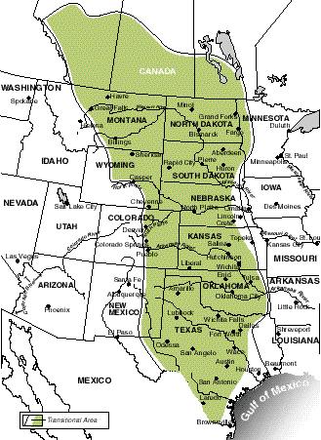

The Eastern Plains
- Occupied by tribes including the __________________ and __________________
- __________________ made __________________ successful
- Built __________ near river
  - ___________________: A home made of bark, earth, grass. Provided protection from cold and stormy weather
- ____________________ in spring and fall
- ____________________ in summer and winter

The Western Plains
- Dry weather = ____________________ ____________________
- Relied on ____________________
- Provided meat
- Bones could be used to make ____________________
- ____________________ could be made into ___________________
- Tail = fly swatter
- _____________________ used for shelter, blankets, clothing, drums, and shields
- Occupied by ________________
  - ________________________: Person who moves around and does not live in one place
  - Carried belongings using a _______________________
    - Travois: Similar to a ___________ , usually pulled by a dog
  - Lived in ________________________ (Cone shaped tent) – Easy to set up and take down

The Comanche
- Skilled horse riders, ___________________, and ____________________
- Brought horses to North America in 1500’s
  - By 1700’s, almost all American Indians had ____________________
  - Made life easier to ________________ and __________________
  - _____________________ measured by how many horses owned
- Migrated from _____________________ to __________________ and
___________________
- Lived as ______________________
- Were _________________ warriors
- Became one of the most powerful ____________________ groups (nations)
- Became known as “The Lords of the Southern Plains”
  - Had _________________ and _________________

Comanche Government
- Divided into groups, hunted and traveled freely
- Chose leaders (_______________)
  - Different chiefs for ______________ and ______________________

Comanche Today
- About ____________________ live in US today
- Most live as farmers/ranchers in ____________________
- Still have own ____________________

