Native Americans: Name:__________________________
Core Lesson 3 NOTES SHEET

The Southwest
- Includes present day ____________________ and ____________________.
- Stretches across Utah, Colorado, Nevada, Texas, southern California, and northern Mexico.
- Includes parts of the ___________________ ___________________.
- Mainly low _________________ ________________, but in some places rises to high
- ____________________.
- Very little ____________________
- Most river water is from ____________________ ____________________ from mountains

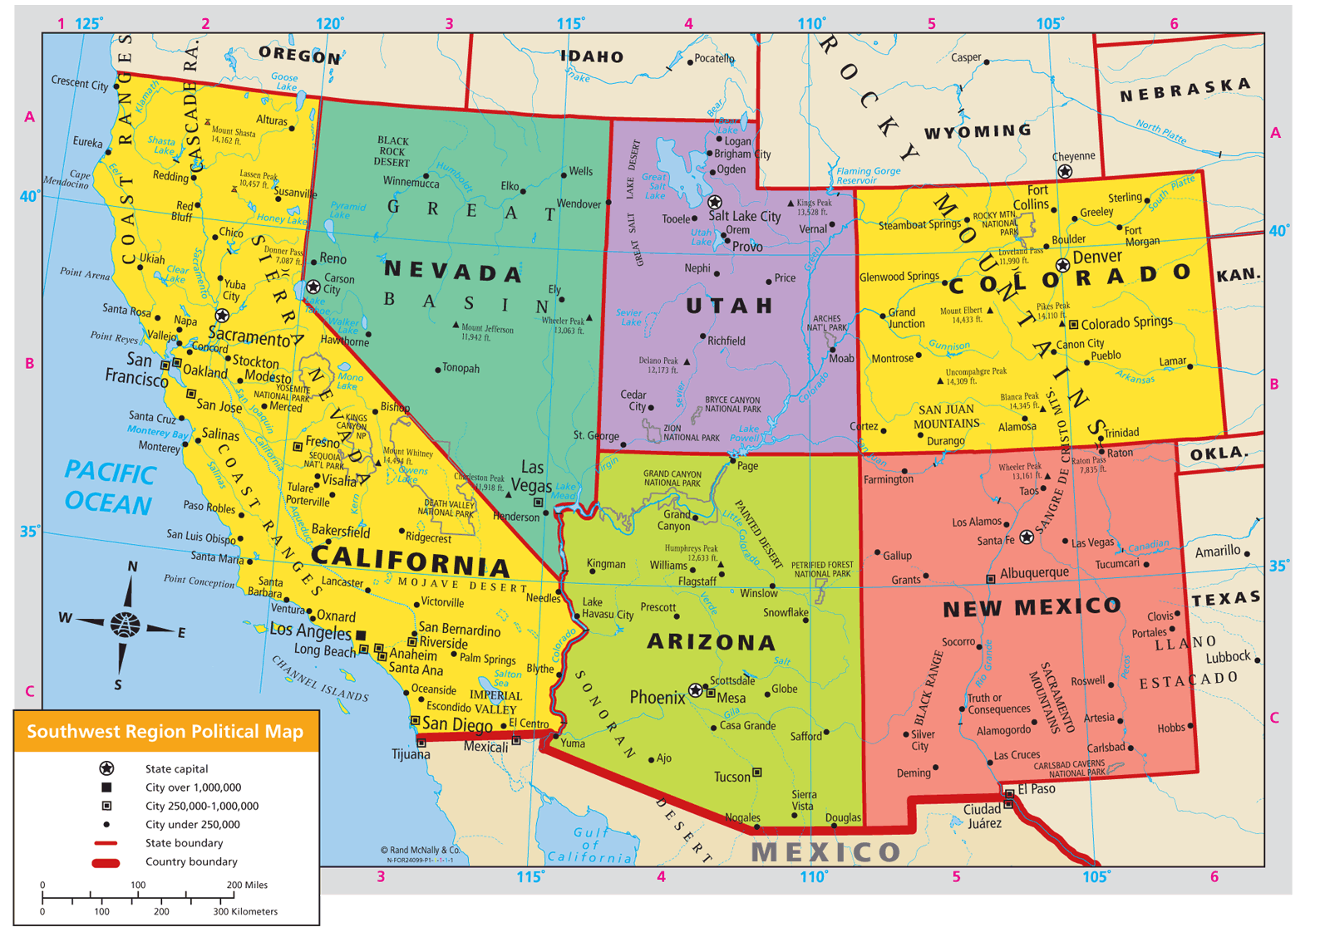
People of the Land
- Climate influenced the way they lived
- Used sticks, stones, and adobe to make houses
  - ____________________ – A type of clay
- Built home on top of mesas to be protected from attack
  - ____________________: Small plateaus with steep sides and flat tops
- Many were farmers; had to find way to water crops due to dryness. Used irrigation
  - ____________________: Way of supplying water to crops with streams, ditches, pipes.
- Also planted corn deep in ground so roots would get moisture

The Hopi
- ____________________ Southwest Indian group
- Used irrigation to grow ________________, _______________, and corn. (staple crop)
  - ____________________: Main crop used for food
- Grew enough ____________________ to last a whole year!
- Used clay to make ____________________ and containers to store food. Were one of the first
people to fire ____________________
- ____________________ was very important
- Meant to be caretakers of the land
- Included prayer and cermonies as way of keeping land healthy
  - ____________________Special event where people gather to express important beliefs.
- The Hopi today:
  - Follow many of their ____________________ ____________________
  - Skilled at making pots, weavings, baskets, and silver jewelry.

